PhD Thesis Title

by

Discipulus nomen

A Dissertation Submitted to the

Graduate School of Health Sciences in Partial Fulfillment of the Requirements for the Degree of

Doctor of Philosophy

in

(name of program)


Month Day, Year

PhD Thesis Title

Koc University

Graduate School of Health Sciences

This is to certify that I have examined this copy of a doctoral dissertation by

Discipulus nomen

and have found that it is complete and satisfactory in all respects,

and that any and all revisions required by the final

examining committee have been made.

Committee Members:

Prof./ Assoc. Prof / Assist. Prof. ABC (Advisor)

Prof./ Assoc. Prof / Assist. Prof. XYZ [Co-Advisor]

Prof./ Assoc. Prof / Assist. Prof. MNO

Prof./ Assoc. Prof / Assist. Prof. DEF

Prof./ Assoc. Prof / Assist. Prof. PQR

Date:

Dedication here (Optional)

iii

ABSTRACT

PhD Thesis Title

Discipulus nomen

Doctor of Philosophy in (name of program) Month Day, Year

Abstract here. Abstract here. Abstract here. Abstract here. Abstract here. Ab-stract here. Abstract here. Abstract here. Abstract here. Abstract here. Abstract here. Abstract here. Abstract here. Abstract here. Abstract here. Abstract here. Abstract here. Abstract here. Abstract here. Abstract here. Abstract here. Ab-stract here. Abstract here. Abstract here. Abstract here. Abstract here. Abstract here. Abstract here. Abstract here. Abstract here. Abstract here. Abstract here. Abstract here. Abstract here. Abstract here. Abstract here. Abstract here. Ab-stract here. Abstract here. Abstract here. Abstract here. Abstract here. Abstract here. Abstract here. Abstract here. Abstract here. Abstract here. Abstract here.

iv

OZETCE

 |  | Doktora Tez Baslığı
 |  | Discipulus nomen
 | Program Adı, |  |  | Doktora
 |  | Gün Ay Yıl
Ozetce burada. Ozetce burada. Ozetce burada. Ozetce burada. Ozetce burada.
Ozetce burada. Ozetce burada. Ozetce burada. Ozetce burada. Ozetce burada.
Ozetce burada. Ozetce burada. Ozetce burada. Ozetce burada. Ozetce burada.
Ozetce burada. Ozetce burada. Ozetce burada. Ozetce burada. Ozetce burada.
Ozetce burada. Ozetce burada. Ozetce burada. Ozetce burada.

v

ACKNOWLEDGMENTS

vi

TABLE OF CONTENTS

List of Tables |  |  | ix
List of Figures |  |  | x
Abbreviations |  |  | xi
Chapter 1: |  | Introduction | 1
Chapter 2: |  | Format of the Thesis | 2
2.1 | Language . . . . . . . . . . . . . . . . . . . . . . . . . . . . . . . . . |  | 2
2.2 | Paper Size and Page Layout . . . . . . . . . . . . . . . . . . . . . . . |  | 2
2.3 | Font and Font Size . . . . . . . . . . . . . . . . . . . . . . . . . . . . |  | 2
2.4 | Pagination . . . . . . . . . . . . . . . . . . . . . . . . . . . . . . . . . |  | 3
2.5 | Headings . . . . . . . . . . . . . . . . . . . . . . . . . . . . . . . . . . |  | 3
 | 2.5.1 First Subsection Heading . . . . . . . . . . . . . . . . . . . . . |  | 3
2.6 | Footnotes . . . . . . . . . . . . . . . . . . . . . . . . . . . . . . . . . |  | 4
2.7 | Tables and Figures . . . . . . . . . . . . . . . . . . . . . . . . . . . . |  | 4
2.8 | Equations . . . . . . . . . . . . . . . . . . . . . . . . . . . . . . . . . |  | 4
2.9 | Bibliography . . . . . . . . . . . . . . . . . . . . . . . . . . . . . . . |  | 5
2.10 | Printing . . . . . . . . . . . . . . . . . . . . . . . . . . . . . . . . . . |  | 6
Chapter 3: |  | ....... | 7
3.1 | Section . . . . . . . . . . . . . . . . . . . . . . . . . . . . . . . . . . . |  | 7
 | 3.1.1 Subsection . . . . . . . . . . . . . . . . . . . . . . . . . . . . . |  | 7
 | 3.1.2 ....... ................................ |  | 7
3.2 ....... .................................... |  |  | 7

vii

3.2.1 ....... ................................ |  | 7
Chapter 4: | Conclusion | 8
Bibliography |  | 9
Appendix A: |  | 10

viii

LIST OF TABLES

2.1 Page layout margin information. . . . . . . . . . . . . . . . . . . . . . 4

ix

LIST OF FIGURES

2.1 Sample plots: (a) the first sample, (b) the second sample. . . . . . . 5

x

ABBREVIATIONS

ASM Active Shape Model

DP Dynamic Programming

PCA Principal Component Analysis

RMSE Root Mean Squared Error

xi

Chapter 1: Introduction | 1

Chapter 1

INTRODUCTION

Start with an introduction.
Chapter 2: Format of the Thesis | 2

Chapter 2

FORMAT OF THE THESIS

2.1 Language

The Thesis must be written English. A Turkish abstract must appear under Ozetce.

2.2 Paper Size and Page Layout

International A4 size paper must be used. Paper must be of good quality and of sufficient opacity for normal reading (of weight 70 gr/m2 to 100 gr/m2). Only one side of the paper must be used.

The page layout should be single column with one and a half spacing used between the lines except the Abstract section. Single spacing should be used in the Abstract. All text pages should be justified. Page margins must comply with the following:

Left margin: 35 mm from the edge of the paper

Right margin: 25 mm from the edge of the paper

Top margin: 25 mm from the edge of the paper

Bottom margin: 25 mm from the edge of the paper

2.3 Font and Font Size

Text must be typed in Times New Roman. Text font-size should be 12-point in-cluding equations, Table headings, Table and Figure captions. Footnotes, long bio-graphical quotes and extensive quotations should be 10-point.
Chapter 2: Format of the Thesis | 3

2.4 Pagination

Each page in the thesis (except the first two title pages) is expected to have a page number.

The preliminary section, including the title page; committee page; dedication or acknowledgments pages, if any; abstract pages; Table of Contents, List of Tables and Figures, and Nomenclature pages should be numbered, using lower case Roman numerals. The Roman numeral page numbers must be at the bottom center of the pages starting from the third page of the thesis.

For the remainder of the thesis, pages must be numbered consecutively through the thesis, starting at the first page of the Introduction using Arabic numerals. The Arabic numeral page numbers must be at the top right side of the pages starting from the Introduction.

2.5 Headings

Headings should be in Times New Roman. There may be at most four levels of headings which are chapter headings, section headings, first subsection headings and second subsection headings. Chapter headings must be centered, bold face, all capital and 14 pt. All section headings must be left adjusted, bold face and 12 pt. The section headings must be slanted, the first and second subsection headings must be italic, and the second subsection headings should not be numbered.

2.5.1 First Subsection Heading

There goes the first subsection...

Second Subsection Heading

There goes the second subsection...

Chapter 2: Format of the Thesis | 4

2.6 Footnotes

Recognizing that there are differences in disciplinary approaches, footnotes should still be used with discretion and when absolutely necessary. They should be placed at the bottom of the page on which they are indicated¹.

Table 2.1: Page layout margin information.

Margin | Length from the edge of the paper (mm)
Left margin | 35
Right margin | 25
Top margin | 25
Bottom margin | 25

2.7 Tables and Figures

Tables and Figures should be enumerated within each chapter, i.e., as 1.1, 1.2, 1.3, 3.1, 3.2, etc. While referring to the tables and gures the first letter should be in capital (i.e, such as Table 2.1 or Figure 2.1). Sub-figures should be enumerated by adding the corresponding lowercase letter, such as Figure 3.1a. The sub-figures should not have captions, their information rather be included in the caption of the Figure.

Table captions should be located above the Tables whereas Figure captions should be placed below the Figures. All captions should end with a period.

2.8 Equations

A sample equation is given as

L( jv) = ln p(v; ): | (2.1)

¹A sample footnote.

Chapter 2: Format of the Thesis | 5
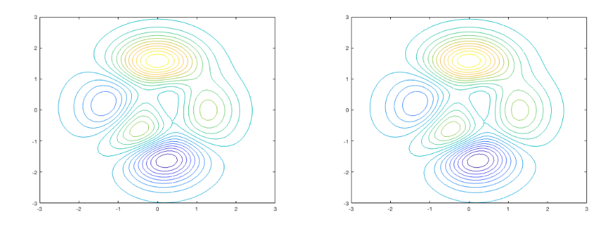

(a) (b)

Figure 2.1: Sample plots: (a) the rst sample, (b) the second sample.

Yet another aligned set of equations are given as

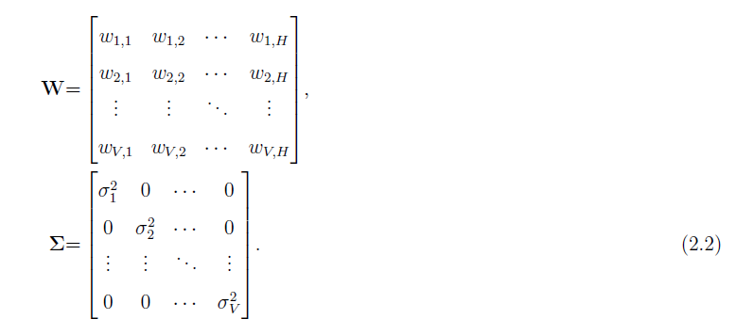

2.9 Bibliography

It is important to follow a consistent citation usage throughout the thesis. Suggested citation usage follows the APA style (surname of the rst author, year) type. Note that depending on the requirements of individual disciplines, the bibliography may follow the IEEE, MLA or Chicago/Turabian styles. Usage for different reference types in the APA style are exemplified in the following. A sample LaTeX bibliography file (references.bib) can be found in the thesis sample package.
This is a sample journal reference with single author [Breazeal, 2003].
This is a sample conference reference with more than two authors [Zhang et al., 2004].
Chapter 2: Format of the Thesis | 6

This is a sample book reference with two authors [Ekman and Friesen, 1975].

This is a sample PhD thesis reference [Cuartas, 2012].

This is a sample MS thesis reference [Krizhevsky, 2009].

This is a sample technical report reference [Roux and Bengio, 2007].

This is a sample web-page reference [GSHS, 2018].

2.10 Printing

Note that the LaTeX generated pdf files will have the designated page layout, however depending on which viewer and operating system that you are printing page layout might have modifications. The best suggested practice is to take the final print directly on the printer through a memory stick.
Chapter 3.......... 7

Chapter 3

.......

3.1 Section

3.1.1 Subsection

3.1.2 .......

3.2 .......

3.2.1 .......
Chapter 4: Conclusion | 8

Chapter 4

CONCLUSION
Bibliography | 9

BIBLIOGRAPHY

[Breazeal, 2003] Breazeal, C. (2003). Toward sociable robots. Robotics and Au-tonomous Systems, 42(34):167 - 175.

[Cuartas, 2012] Cuartas, G. F. M. (2012). On the Expressive Power of Discrete Mixture Models, Restricted Boltzmann Machines, and Deep Belief Networks - A Uni ed Mathematical Treatment. PhD thesis, University of Leipzig.

[Ekman and Friesen, 1975] Ekman, P. and Friesen, W. (1975). Unmasking the Face: A Guide to Recognizing Emotions from Facial Clues. Spectrum books. Prentice-Hall.

[GSHS, 2018] GSHS (2014 (accessed December 31, 2018)). Graduation checklist.

https://gshs.ku.edu.tr/en/current-students/graduation-guidelines/

[Krizhevsky, 2009] Krizhevsky, A. (2009). Learning multiple layers of features from tiny images. Master’s thesis, University of Toronto.

[Roux and Bengio, 2007] Roux, N. L. and Bengio, Y. (2007). Representational power of Restricted Boltzmann Machines and Deep Belief Networks. Technical report, Universite de Montreal.

[Zhang et al., 2004] Zhang, Z., Liu, Z., Sinclair, M., Acero, A., Deng, L., Droppo, J., Huang, X., and Zheng, Y. (2004). Multi-sensory microphones for robust speech detection, enhancement and recognition. In The International Conference on Acoustics, Speech, and Signal Processing, ICASSP, volume 3, pages 781-784.
Appendix A: | 10

Appendix A

Appendix goes here.

